MY IMAGE

WEB

APPLICATION

**Documentation of e-Project**

|  |  |
| --- | --- |
| **Muhammad Huzaifa** | **Student_1175352** |
| **Hafiz Muhammad Waqas** | **Student_1235313** |
| **Syed Muhammad Ahmed Khurshid** | **Student_1204060** |

|  |  |
| --- | --- |
| **Razi waheed** | **Student_1175940** |

**Submitted To :** **eProjects@algsm.com**

**Project Instructor : MISS ANUSHEH NAWAZI**

**Curriculum Code : OV-6740**



**Table of Contents**

|  |  |  |  |
| --- | --- | --- | --- |
| **Documentation of e-Project….…………………….…………………………………………..** | | | 1 |
|  | | |  |
| **TABLE OF CONTENTS………………………………………………………………………………..……** | | | 2-3 |
|  | | |  |
| **INTRODUCTIOn……………………………………………………………………………………………..** | | | 4 |
|  | | |  |
| **bENEFITS OF EPROJECTS………………………………………………………………………………** | | | 5 |
| **dedication ……………………………………………………………………………………………..….** | | | 6 |
|  | | |  |
| **Acknowledgements…………..……………………………………………………………………….** | | | 7 |
| **CERTIFICATION……………………………………………………………………………………………..** | | | 8 |
|  | | |  |
| **Objectives of the PROJECT ……………………………………………..………………………..** | | | 8 |
|  | | |  |
| **reqirement specification………………………………………………………………………….** | | | 9 |
|  | **OUR OBECTIVE ………………………………………………………………………………………** | | 8 |
|  |  | |  |
|  | **HARDWARE/SOFTWARE REQUIREMENTS ………………………………………………….** | | 11 |
|  |  | **HARDWARE …………………………………………………………………………… 11** |  |
|  |  | **SOFTWARE ……………………………………………………………………………. 11** |  |
|  | | |  |
| **SOFTWARE USED …………………………………………………………………………………………..** | | | 11 |
| **PROJECT PLAN………………………………………………………………………………………………** | | | 12 |
|  | | |  |
| **PROJECT DURATION ………………………………………………………………………………………** | | | 14 |
|  | | |  |
| **TASK SHEET …………………………………………………………………………………………………** | | | 15 |
|  | | |  |
| **SUBMITION CHECKLIST ……………………………………………………………………………….…** | | | 16 |
| **List of validations …………………………………………………………………………….** | | | 17 |
| **SNAP SHOTS ………….……………………………………………………………………………………..** | | | 18 |
| **ER diagram………………………………………………………………………….. 18**  **Home Page……………………………………………………………………………… 19**  **Product Page………………………………………………………………….. 20**  **Contact us Page…………………………………………………………….……… 21**  **project review and monitoring report………………………………………………………** | | | 22-28 |

**INTRODUCTION**

* The thirst for learning, upgrading technical skills and applying the concepts in real life environment at a fast pace is what the industry demands from IT professionals today. However busy work schedules, far-flung locations, and unavailability of convenient time-slots pose as major barriers when it comes to applying the concepts into realism. And hence the need to look out for alternative means of implementation in the form of laddered approach.
* The above truly pose as constraints especially for our students too! With their busy schedules, it is indeed difficult for our students to keep up with the genuine and constant need for integrated application which can be seen live especially so in the field of IT education where technology can change on the spur of a moment. Well,technology does come to our rescue at such times!!
* Keeping the above in mind and in tune with our constant endeavour to use Technology in our training model, we at Aptech have thought of revolutionizing the way our students learn and implement the concepts using tools themselves by providing a live and synchronous eProject learning environment!

**Benefits of eProject :**

* Re-enforcement of Skills happens in the experiential learning process.
* A mentor, ensuring that you do not get drifted, constantly guides you.
* It gives you a lot of confidence to face an interview as you have worked on a project. You can explain virtually everything on the subject you have learnt.
* A nice, final, black, hardbound report adds to you credentials and enhances your job prospects.

**DEDICATION**

* To our teacher Miss Anusheh Nawazi of Aptech, without her support and kind contribution, it would have been a difficult task to accomplish.
* To our parents, who have always been our sources of inspiration and always support us in study.
* To all Aptech who help us in making this project and support us.

**ACKNOWLEDGEMENT**

We are extremely grateful and remain indebted to our guide Miss. Anusheh Nawazi for being a source of inspiration and for her constant support in the Design and development of the e-project. We are thankful to her for their constant constructive criticism and invaluable suggestions, which benefited us a lot while developing the e-project on **“Web-Application MY IMAGE”.** She has been a constant source of inspiration and motivation for hard work. She has been very co-operative throughout this e-project work. Through this column, it would be our outmost pleasure to express our warm thanks to her for their encouragement, co-operation and consent without which we mightn’t be able to accomplish this e-project.

We also express our gratitude to Aptech for providing us the infrastructure to carry out the project and to all staff members who were directly and indirectly instrument in enabling us to stay committed for the **e-project**.

**Certification**

**CERTIFICATE**

This Is To Certify That, Muhammad Huzaifa, Hafiz Muhammad Waqas, Syed Muhammad Ahmed & Razi Waheed Of Batch 1909B2 Successfully Designed & Developed “MY IMAGE".

**Date Of Issue: 28th Jan-2021**

**Date Of Submission: 27th Feb-2021**

AUTHORIZED SIGNATURE: MISS. ANUSHEH NAWAZI

AUTHORIZED SIGNATURE: SIR. ABDUL WAHAB KHAN

**Objectives of the project**

The Objective of this program is to give a sample project to work on real life

projects. These applications help you build a larger more robust application.

The objective is not to teach you the software’s but to provide you with a real life

scenario and help you create basic applications using the tools.

You can revise the topics before you start with the project.

These programs should be done in the Lab sessions with assistance of the faculty if

required.

It is very essential that a student has a clear understanding of the subject.

Kindly get back @ **eProjects@aglsm.com** in case of any doubts regarding the

application or its objectives.

**Requirement Specifications**

Our client, My Image wants the following actions to be implemented.

* The users have to register himself with the site before using the
* functionality. After registrations user id and password will be
* provided to the user. Through which he can login.
* The price information for the different print sizes will be stored in
* the database.
* The user will upload JPEG files from his desktop, which he wants
* to print.
* The application will show all the jpeg files in the folder to the
* user. The user can then choose the size(s) and the number of
* prints that he/she wants to print for each size for each
* photograph.
* The application will calculate the total price for the order.
* If the user decides to buy the prints, he/she will be asked to
* enter the mode of payment (credit card/direct payment in the
* nearest branch office) and the shipping address. If credit card
* option is chosen, the credit card information will be encrypted
* and sent to the server for verification.
* The server will decrypt the credit card information and verify it.
* If found correct, payment will be completed.
* A purchase request will be created in the database. The
* purchase order number will be provided to the user
* An administrator user then can see the purchase request and
* can execute the same.
* Once the photos are printed and shipped, the directory
* containing these photographs will be deleted from the server.
* The admin will decide the price and other things. Proper
* validation should be applied.

**Hardware/ Software Requirements**

**Hardware**

* A minimum computer system that will help you access all the tools in the courses is a Pentium 166 or better
* 128 Megabytes of RAM or better

**Software**

Use software as per your requirement

* Visual Studio .Net / ASP
* IIS server
* .Net Framework
* Java Virtual Machine/ J2EE server
* Notepad/Java editor
* j2sdk1.4.1_02 (or later).
* EJB Dev Kit
* Java enabled web server
* JSP / Servlets Dev. Kit

# PROJECT PLAN

Our Plan And Our Idea Was To Provide Maximum Output In The Minimum Time. We Tried To Make Our Database Secure And Well Managed And Made Our Interface User Friendly So That Every Customer Can Print Easily. We Make An Easiest Way To Full Fill Form Requirement.

# PROJECT DURATION

1. Analysis -1 -7.
2. Database -3 -7.
3. Design - 4-16.
4. Development - 9-27.
5. Testing - 24-29.
6. Documentation - 29-30.

|  |  |  |  |  |  |
| --- | --- | --- | --- | --- | --- |
| **Analysis** | **Database** | **Design** | **Development** | **Testing** | **Documentation** |

|  |  |  |  |  |  |  |  |  |  |  |  |  |  |  |  |  |  |  |  |  |  |  |  |  |  |  |  |  |  |
| --- | --- | --- | --- | --- | --- | --- | --- | --- | --- | --- | --- | --- | --- | --- | --- | --- | --- | --- | --- | --- | --- | --- | --- | --- | --- | --- | --- | --- | --- |
| 1 | 2 | 3 | 4 | 5 | 6 | 7 | 8 | 9 | 10 | 11 | 12 | 13 | 14 | 15 | 16 | 17 | 18 | 19 | 20 | 21 | 22 | 23 | 24 | 25 | 26 | 27 | 28 | 29 | 30 |

**Task Sheet**

|  |  |  |  |  |  |
| --- | --- | --- | --- | --- | --- |
| S.No | Task | Project Title | Actual Start  Date | Actual Days | Status |
| **Online Jewelry Shopping** |
| 1. | Case Study | | 28-Jan-2021 | 2 | Completed |
| 2. | Database Designing | | 30- Jan -2021 | 9 | Completed |
| 3. | Material Searching | | 7- Feb -2021 | 2 | Completed |
| 4. | Development | | 24- Feb -2021 | 17 | Completed |
| 5. | Testing | | 26- Feb -2021 | 2 | Completed |
| 6. | Documentation | | 28- Feb -2021 | 2 | Completed |

**Submission Checklist**

|  |  |  |  |
| --- | --- | --- | --- |
| S.NO | LIST OF ITEMS | Remarks | COMMENTS |
| 1. | Do All Pages Linked together | **Yes** |  |
| 2. | All Hyperlinks working | **Yes** |  |
| 3. | Page Colors As Per Common Guidelines | **Yes** |  |
| 4. | Image | **Yes** |  |
| 5. | Feedback Form Included | **Yes** |  |
| 6. | Project Zip File | Yes | Created using WinRAR |

**LIST OF VALIDATION**

|  |  |
| --- | --- |
| OPTIONS | VALIDATION |
| All Forms have link back to Main Form | Yes |
| All Functions Are Compatible with  Visual Studios | Yes |

**Snap Shots**

# ER Diagram:

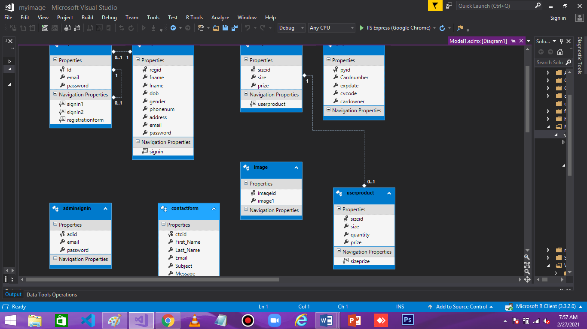

# Home Page:

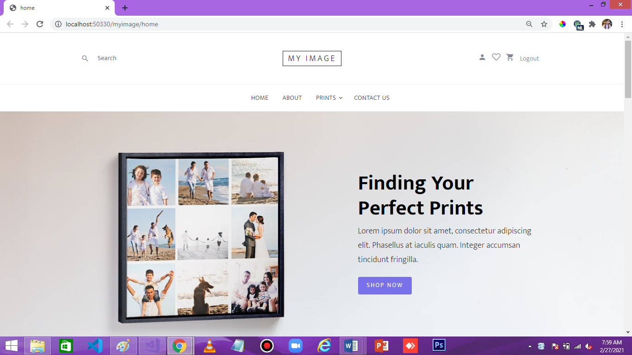

# Product Page:

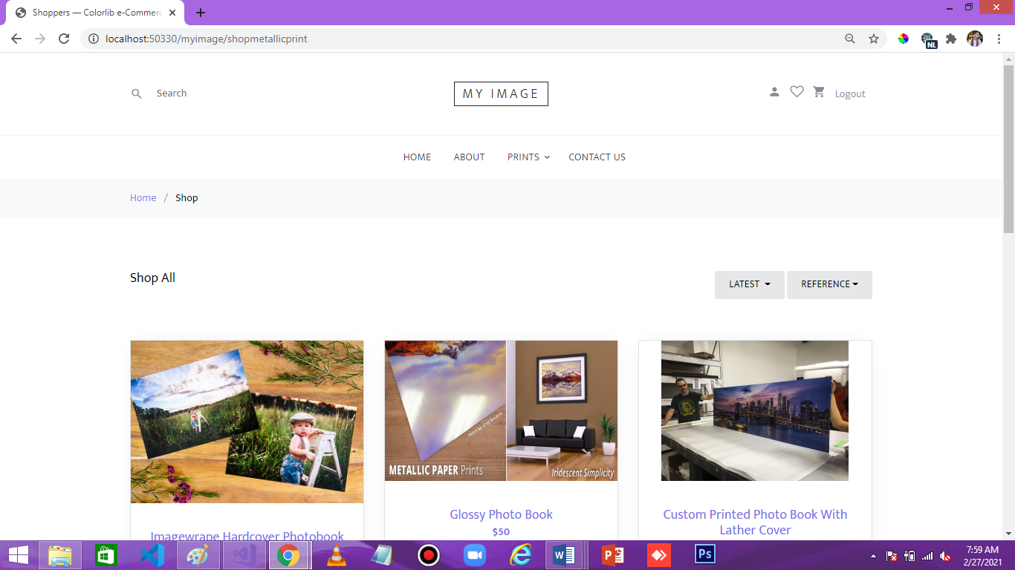

# Contact Us:

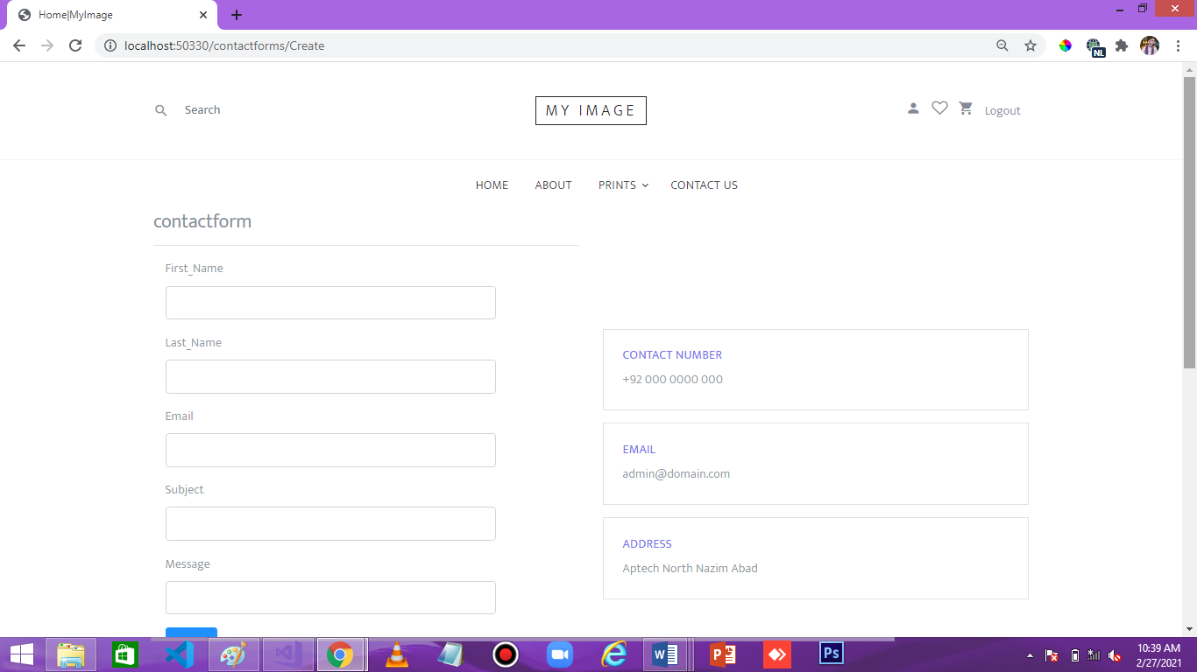

# About Us:

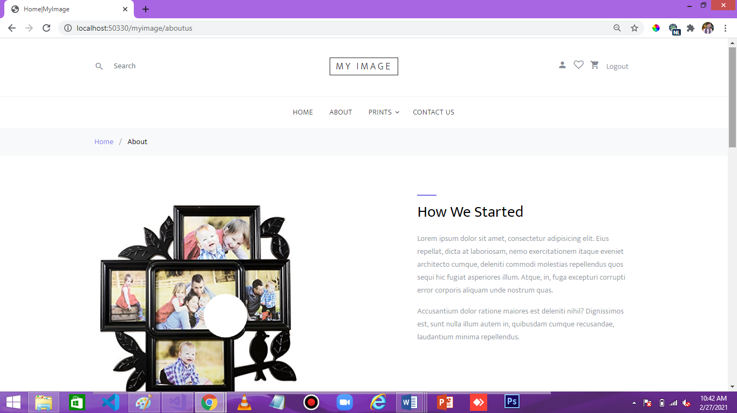

# Select Size for Print:

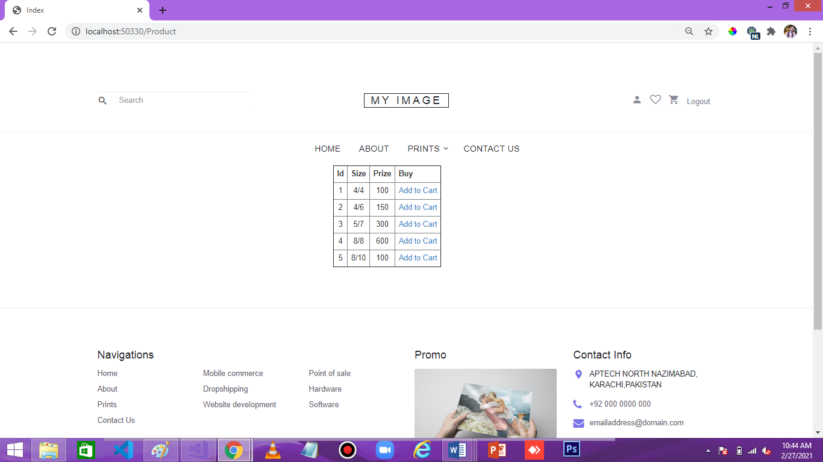

# User Cart:

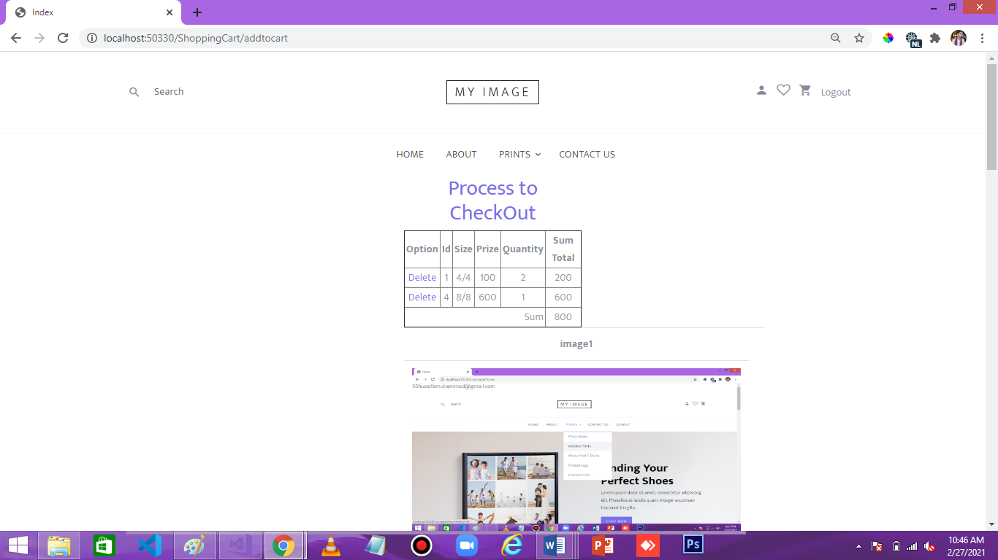

# Add Shipping Detail:

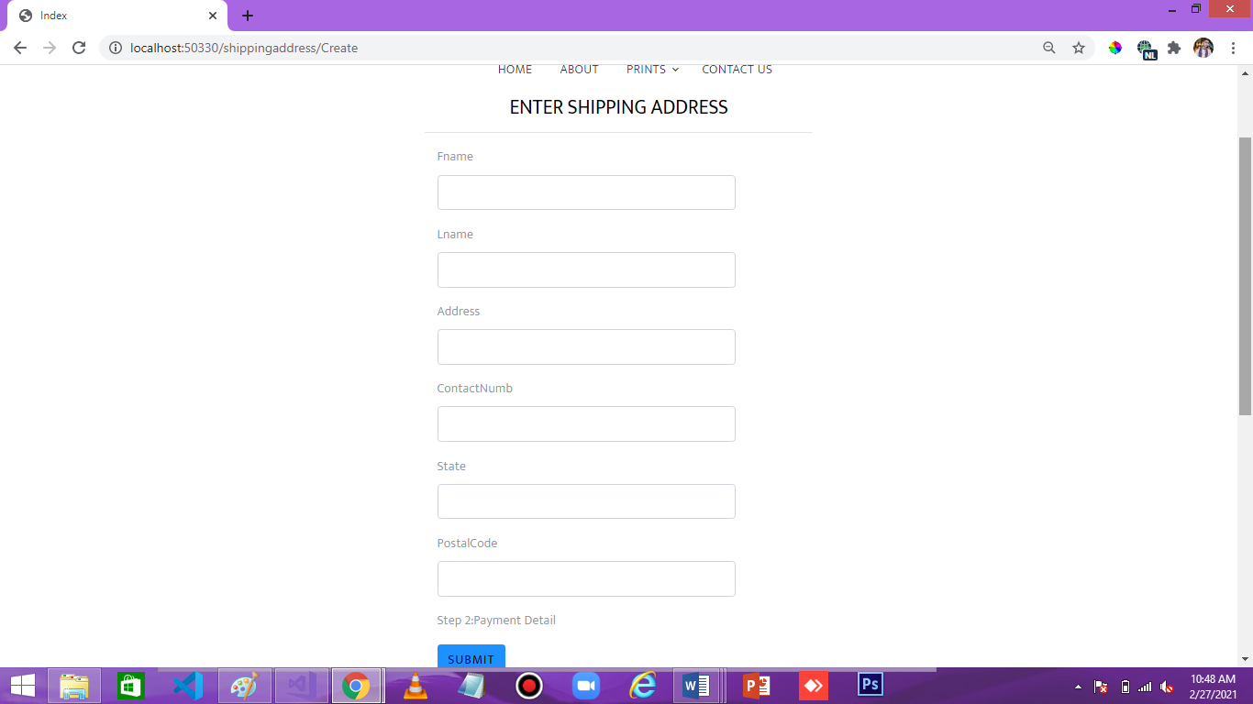

# Add Payment Detail:

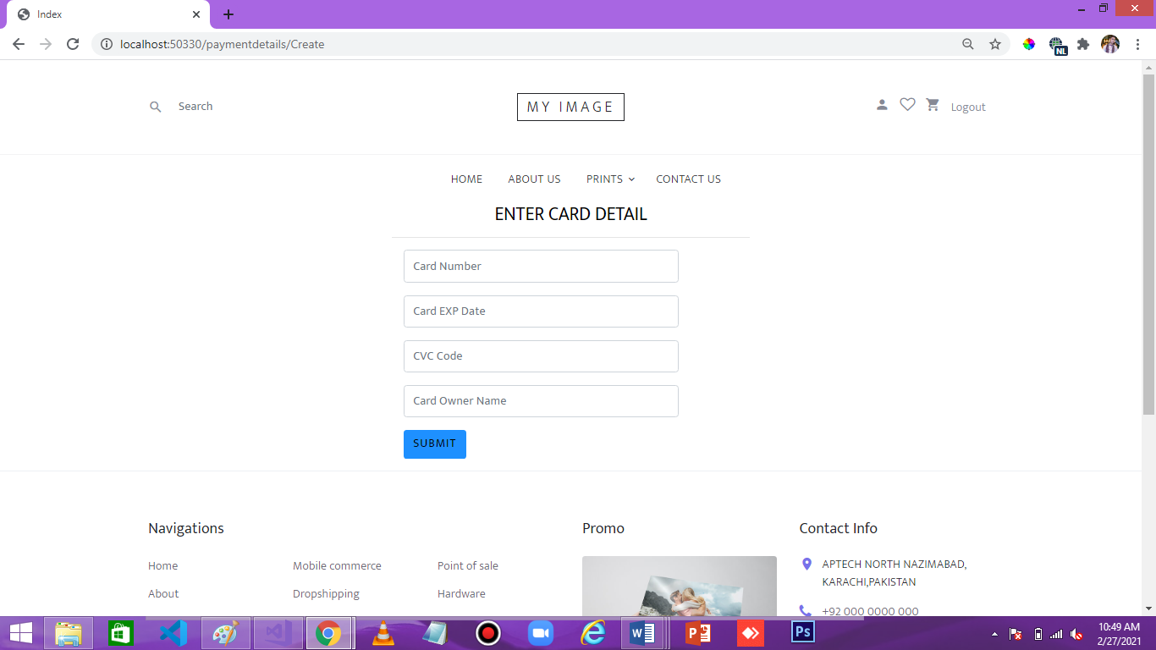

# Dashboard:

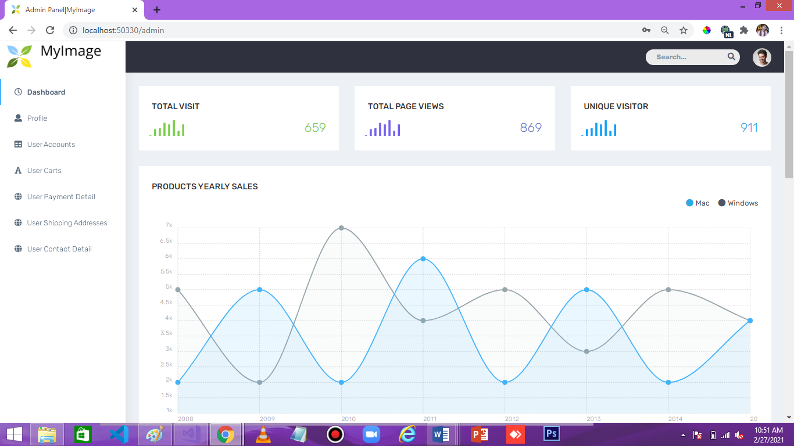

Project Review And Monitoring Report

First Of All, Group Projects Force You To Work With Your Group Members. Unfortunately, As We All Know, Is Doesn’t Happened Before But In This The Real Mirrors World, Where You Don’t Get To Choose Your Co-Workers. Learning How To Deal With Someone Who Slacks, Is Confrontational Or Is Nonresponsive Is Imperative To Have A Happy And Successful Work Life.

We’ve Learned How To Work Together As A Team, What To Do, Such A Nice Criteria Of Studies We Have By Aptech , How To Contribute In Ideas, Our Minds Start Resolving Errors, And Giving Us Many Ideas. Whole Team Is So Much Thankful To Aptech Learning, For Giving Us An Opportunity To Explore Ourselves, We’ve To Learned Or Practices More & More To Make Our Skills Best.

As It Was Our Second Semester (DISM) Project Of MVC(.NET), WeWould Like To Express Our Special Thanks To Our Faculty **MISS ANUSHEH NAWAZI** , Who Helped Us Through Thick And Thin And Guided Us Like A Real Mentor, We Would Like To Thanks Our Batch Co-Ordinator As Well, **MISS FAREEHA ALAM** Who Gave Us The Golden Opportunity To Do This Wonderful Project Of **MY IMAGE**, Which Also Helped Us To Master Our Skills In Designing, Programming And Database And We Came To Know About So Many New Things We Are Really Thankful To Them.

**THANKYOU APTECH LEARNING PAKISTAN**